ONLINE APPOINTMENT FOR HEALTHCARE CLINIC

Business Requirements Document (BRD)

|  |  |  |  |
| --- | --- | --- | --- |
| Author | Version | Date | Description |
| Zohaib Waqar | 1.0 |  |  |

Table of Contents

**Author Change Control & Approvers2**

**Executive Summary3**

**Glossary3**

**User Personas4**

**Business Goals4**

**Project Overview & Objectives4**

Overview4

Objectives4

**Project Scope5**

In Scope5

Out of Scope5

**Success Criteria5**

**Current State5**

**Target State5**

**RAID (Risks, Assumptions, Issues, Dependencies)6**

**Major Requirements6**

**Business Rules8**

**Data Privacy & Security Requirements8**

**Accessibility Considerations** **9**

**Business Process Flow9**

**Reports & KPI9**

**Reference Documents10**

**Project Schedule (High-Level Milestones)10**

1. **Author Change Control and Approvers**

|  |  |  |  |  |
| --- | --- | --- | --- | --- |
| Role | Name | Organization | Signature | Date |
| Author | Zohaib Waqar | My Org |  |  |
| Reviewer  (IT Manager) | - | Healthcare Clinic |  |  |
| Project Sponsor | - | Healthcare Clinic |  |  |
| Approver (PO/Stakeholder) | Manager  (IT Operations) | Healthcare Clinic |  |  |

1. **Executive Summary**

This project aims to automate the appointment booking system of a healthcare clinic to overcome the inefficiencies of the existing manual process. Issues like double bookings, poor reporting, and scheduling conflicts will be addressed. Automation will streamline operations, enhance user experience, and support better decision-making via reporting and data analytics.

1. **Glossary**

|  |  |
| --- | --- |
| Term | Definition |
| MoSCoW | Must, Should, Could, Won’t – prioritization framework |
| No-show | A patient who misses an appointment without prior cancellation |
| Rescheduling | Process of changing the date/time of a booked appointment |
| Role-Based Access | Access control based on user role (e.g., Doctor, Admin, Patient) |
| Audit Log | A system-generated record of changes or access for compliance purposes |
| UAT | User Acceptance Testing – the process where end users validate the system meets requirements |
| EMR | Electronic Medical Record – digital version of a patient's paper chart (mentioned in Out of Scope) |
| BPMN | Business Process Model and Notation – a standard for modeling business workflows |
| KPI | Key Performance Indicator – measurable value to track performance/success |

1. **User Personas**
   1. **Tech-Savvy Patient**
      1. Age: 25-40
      2. Comfortable with online bookings, expects smooth mobile experience
   2. **Elderly Patient**
      1. Age: 60+
      2. May need a simple interface and clear guidance
   3. **Busy Doctor**
      1. Needs to view/edit schedule quickly and efficiently
   4. **Clinic Admin**
      1. Manages waitlists, reschedules, and no-shows daily
2. **Business Goals**
   1. Eliminate manual appointment scheduling inefficiencies
   2. Improve patient access and reduce booking-related frustration
   3. Enable data-driven decision-making with automated reporting
   4. Reduce operational overhead for administrative and medical staff
3. **Project overview and Objectives**
   1. **Overview**

The project involves implementing a digital platform for scheduling and managing appointments.

* 1. **Objectives**
     1. Automate booking, rescheduling, and cancellations
     2. Display real-time doctor availability
     3. Enable SMS/email reminders
     4. Ensure secure, role-based system access
     5. Track appointment data and generate reports

The system’s high-level data flow and boundaries are illustrated in the System Context Diagram (**see Appendix ‘A’**)

1. **Project Scope**
   1. **In Scope**
      1. Appointment scheduling and reminders
      2. Manual override by doctors
      3. Appointment audit trail
      4. Role-based access
      5. Reports (appointments, cancellations, no-shows)
   2. **Out of Scope**
      1. Patient billing automation
2. **Success Criteria**
   1. 90%+ reduction in double bookings within 2 months
   2. 70%+ reduction in missed appointments (no-shows) due to reminders
   3. User satisfaction score of 8+/10 in post-deployment survey
   4. System uptime of 99% in the first 6 months
3. **Current State**
   1. Manual scheduling via phone and appointment book
   2. Frequent double bookings and scheduling errors
   3. No consistent reporting mechanism
   4. Financial tracking is handwritten and error-prone
   5. Waitlist and urgent request handling is ad-hoc
4. **Target State**
   1. Online self-service appointment booking system
   2. Centralized, digital schedule with real-time availability
   3. Automated appointment reminders
   4. Manual override for doctors with audit logs
   5. Consistent reporting and analytics dashboards
   6. Manual payment tracking continues (by policy)

The system’s high-level data flow and boundaries are illustrated in the System Context Diagram (**see Appendix ‘A’**)

1. **RAID (Risks, Assumptions, Issues, Dependencies)**

|  |  |
| --- | --- |
| Type | Description |
| Risk | Resistance to change from staff used to manual processes |
| Risk | Peak time load on server causing lags |
| Assumption | Doctors will maintain availability in the system |
| Issue | Finance department prefers to retain manual payments |
| Dependency | Accurate doctor availability and room assignment schedules |

1. **Major Requirements**
   1. **Must Have (Critical to system success)**

|  |  |  |
| --- | --- | --- |
| Requirement | Source | Justification |
| Automated appointment booking | Stakeholder interviews | Core functionality which addresses the biggest pain points. |
| Avoid double bookings | All stakeholders | Major issue across doctors/admin.  system must prevent this. |
| Appointment rescheduling and cancellation | Stakeholders | High frequency task. currently error-prone. |
| Real-time doctor availability view | Admin, Doctors | Necessary for scheduling and avoiding conflicts. |
| Automated appointment reminders (SMS/email) | Admin, Patients | High impact on reducing no-shows and admin load. |
| Manual override for doctors | Doctors,  Manager (IT) | Needed flexibility for real-world situations. |
| Appointment audit logs | Manager (IT) | For accountability and compliance. |
| Role-based access (admin, doctor, patient) | Implied | Basic system integrity and security. |
| System-generated reports (appointments, no-shows) | Doctors, Finance | Needed for operational insights. |

* 1. **Should Have (Important but not vital on day 1)**

|  |  |  |
| --- | --- | --- |
| Requirement | Source | Justification |
| Waitlist Management | Admin staff | Helpful for handling overflow; not immediately critical. |
| Urgent appointment tagging & prioritization | Admin, Manager | Not all clinics need this fully automated right away. |
| Doctor efficiency/performance reporting | Doctors, Manager | Useful for planning and reviews, but not urgent. |
| Analytics dashboard (e.g., time slot usage, patient trends) | Document analysis | Useful but can be part of phase 2. |

* 1. **Could Have (Nice to have If time/resources permit)**

|  |  |  |
| --- | --- | --- |
| Requirement | Source | Justification |
| Patient rating/feedback post-visit | Not directly mentioned | Adds value but non-critical. |
| Chatbot for peak hour call handling | Document analysis | Addresses traffic but may require more tech support. |
| Patient self-registration and profile management | Implied | Enhances UX, can be added after core system is stable. |
| Multi-language support | Not mentioned | Depends on demographics, so optional. |

* 1. **Won’t Have (Out of scope for now)**

|  |  |  |
| --- | --- | --- |
| Requirement | Source | Justification |
| Integrated payment gateway | Finance, Manager | Manager explicitly stated manual payments will continue. |
| Patient diagnosis tracking | Doctors (optional) | Treads into EMR territory, not in initial scope. |

The main user interactions and system functionalities are represented in the Use Case Diagram (**refer to Appendix ‘B’**).

1. **Business Rules**
   1. Doctors can manually adjust their schedule; all changes are logged
   2. Patients cannot book overlapping appointments
   3. Rescheduling must occur at least 24 hours in advance (configurable)
   4. Only admins can manage waitlists and urgent requests
   5. Access is restricted by role with granular permission levels
2. **Data Privacy & Security Requirements**
   1. Ensure all patient data is encrypted in transit and at rest.
   2. Implement HTTPS for all communications.
   3. Comply with HIPAA (if applicable).
   4. Role-based access to restrict sensitive info.
   5. Data retention policy: Archive data older than 12 months, auto-delete after 24 months.
3. **Accessibility Considerations**
   1. Follow WCAG 2.1 AA standards.
   2. High contrast UI and screen reader compatibility.
   3. Font resizing and keyboard navigation support.
4. **Business Process Flow**

The end-to-end process of appointment booking and management is depicted in the BPMN Diagram (see **Appendix C**).

1. **Reports & KPIs (Expanded)**
   1. **Operational Reports**
      1. Daily appointment summary (by doctor)
      2. No-show rate per doctor/week
      3. Top 5 time slots by demand
   2. **Admin KPIs**
      1. Call volume reduction (pre/post deployment)
      2. Time saved per day by staff
   3. **System KPIs**
      1. System uptime (goal: 99%)
      2. Avg. booking/rescheduling time
2. **Reference Documents**
   1. [Requirements Elicitation - Questionnaires – Manager (IT Operations)](https://github.com/ZohaibWaqarMalik/Technical-Business-Analyst-Projects/blob/main/Online-Appointment-for-Healthcare-Clinic/01-Requirements%20Elicitation/02%20-%20Requirements%20Elicitation%20-%20Questionaries%20-%20Manager%20(IT%20Operations).pdf) ​
   2. [Requirements Elicitation - Questionnaires - Stakeholders](https://github.com/ZohaibWaqarMalik/Technical-Business-Analyst-Projects/blob/main/Online-Appointment-for-Healthcare-Clinic/01-Requirements%20Elicitation/03%20-%20Requirements%20Elicitation%20-%20Questionaries%20-%20Stakeholders.pdf)
   3. [Requirements Elicitation - Document Analysis](https://github.com/ZohaibWaqarMalik/Technical-Business-Analyst-Projects/blob/main/Online-Appointment-for-Healthcare-Clinic/01-Requirements%20Elicitation/04%20-%20Requirements%20Elicitation%20-%20Document%20Analysis.pdf)
   4. [Requirement Prioritization - MoSCoW](https://github.com/ZohaibWaqarMalik/Technical-Business-Analyst-Projects/blob/main/Online-Appointment-for-Healthcare-Clinic/01-Requirements%20Elicitation/05%20-%20Requirement%20Prioritization%20-%20MoSCoW.pdf)
3. **Project Schedule (High-Level Milestones)**

|  |  |
| --- | --- |
| Phase | Timeline |
| Requirements Gathering | Completed |
| Design & Wireframing |  |
| Development (MVP) |  |
| UAT & Feedback |  |
| Go-Live |  |
| Post-Go-Live Support |  |

**Appendix ‘A’**

**System Context Diagram**

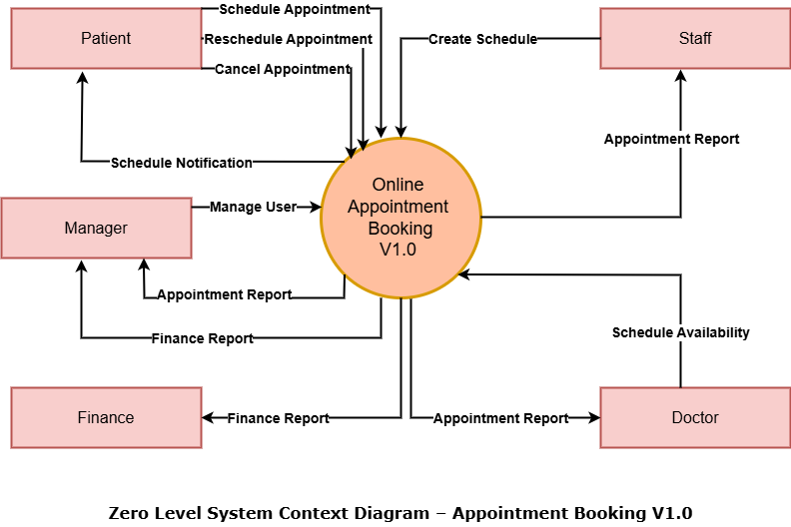

**Appendix ‘B’**

**System Context Diagram**

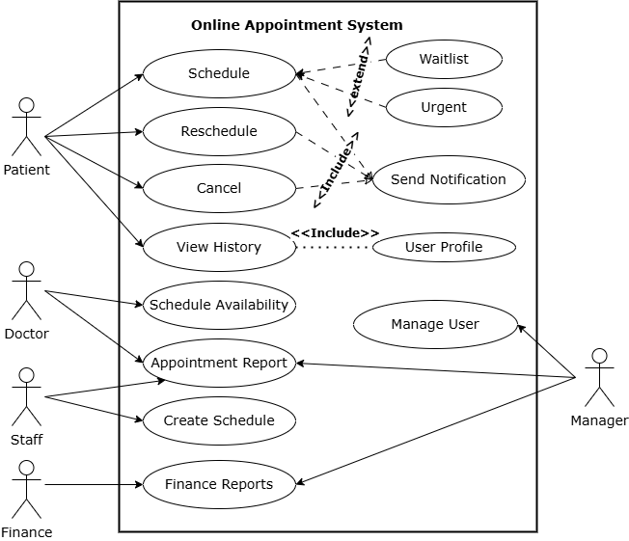

**Appendix ‘C’**

**Business Process Model and Notation**

